Apply filters to SQL queries

Project description
This project focuses on the use of SQL to query a database from the perspective of a security analyst. In this project, I explored various SQL filtering techniques used to retrieve specific information from a database and support task completion efficiently.

The project covers the use of SQL filters and operators such as AND, O R, and NOT, alongside comparison operators including greater than (">"), less than ("<"), greater than or equal to (">="), and pattern-matching commands such as LIKE.

These commands and filters allow me to query databases effectively, retrieve relevant information, and perform analytical tasks successfully. Through this project, I gained practical experience in using SQL to filter and analyze data in a structured and efficient manner.

Retrieve after hours failed login attempts
To investigate failed login attempts outside of official working hours, I used the following SQL query:

SELECT *
FROM log_in_attempts
WHERE login_time > ‘18:00’
AND success = ‘0’;

Query Explanation

The first part of the query, "SELECT *", instructs the database to retrieve all available columns from the table. This allows me to view complete information related to each login attempt, including details such as the username, IP address, location, login time, and event ID.

The "FROM login_attempts" statement specifies the table from which the data should be retrieved. In this case, the query targets the "login_attempts" table, which contains records of user login activities.

The "WHERE" clause is used to apply conditions and filter the data. The first condition, "login_time > 18:00", tells the database to retrieve only login attempts that occurred after 6:00 PM (18:00 hours), which is outside the company’s official working hours.

The "AND" operator is then used to combine multiple conditions. This ensures that the database returns records only when both criteria are met.

The second condition, "success = 0", filters for login attempts that were unsuccessful or failed. In this system, a value of "0" represents a failed login attempt, while successful logins are represented differently.

By combining these conditions, the query helps identify failed login attempts that occurred after official closing hours, enabling further investigation into potentially suspicious or unauthorized access attempts.
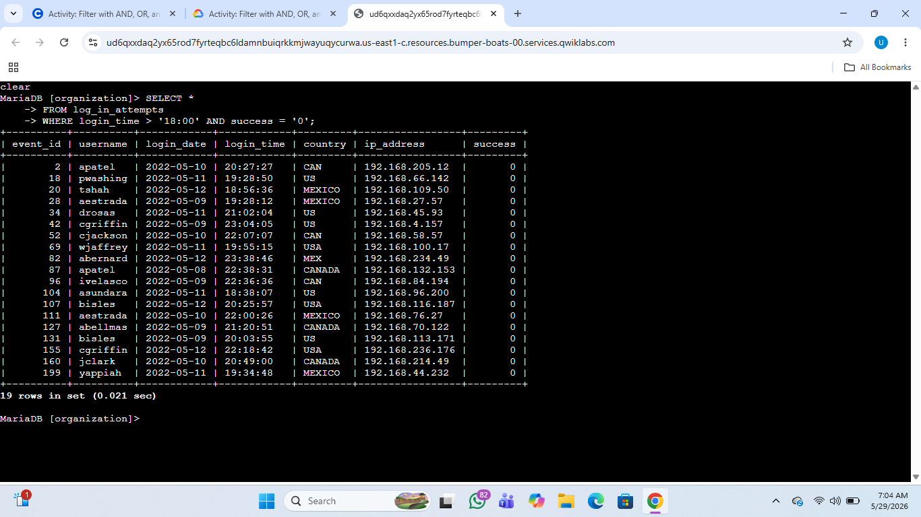

Retrieve login attempts on specific dates
To retrieve login attempts that occurred on May 8, 2022, and May 9, 2022, I used the following SQL query:

SELECT *
FROM log_in_attempts
WHERE login_date = '2022-05-08'
OR login_date = '2022-05-09';

Query Explanation

This query was designed to retrieve login attempts that occurred on two specific dates: May 8, 2022, and May 9, 2022.

The "WHERE" clause is used to filter records based on a condition. In this case, the condition checks the "login_date" field to identify login attempts that match the required dates.

The "OR" operator is used because the query needs to return records that match either one condition or another. Specifically, the query searches for records where the login date is May 8, 2022, or May 9, 2022.

This means that all results returned by the query must contain login attempts that occurred on either of these two dates. Any records outside of these specified dates are excluded from the output.
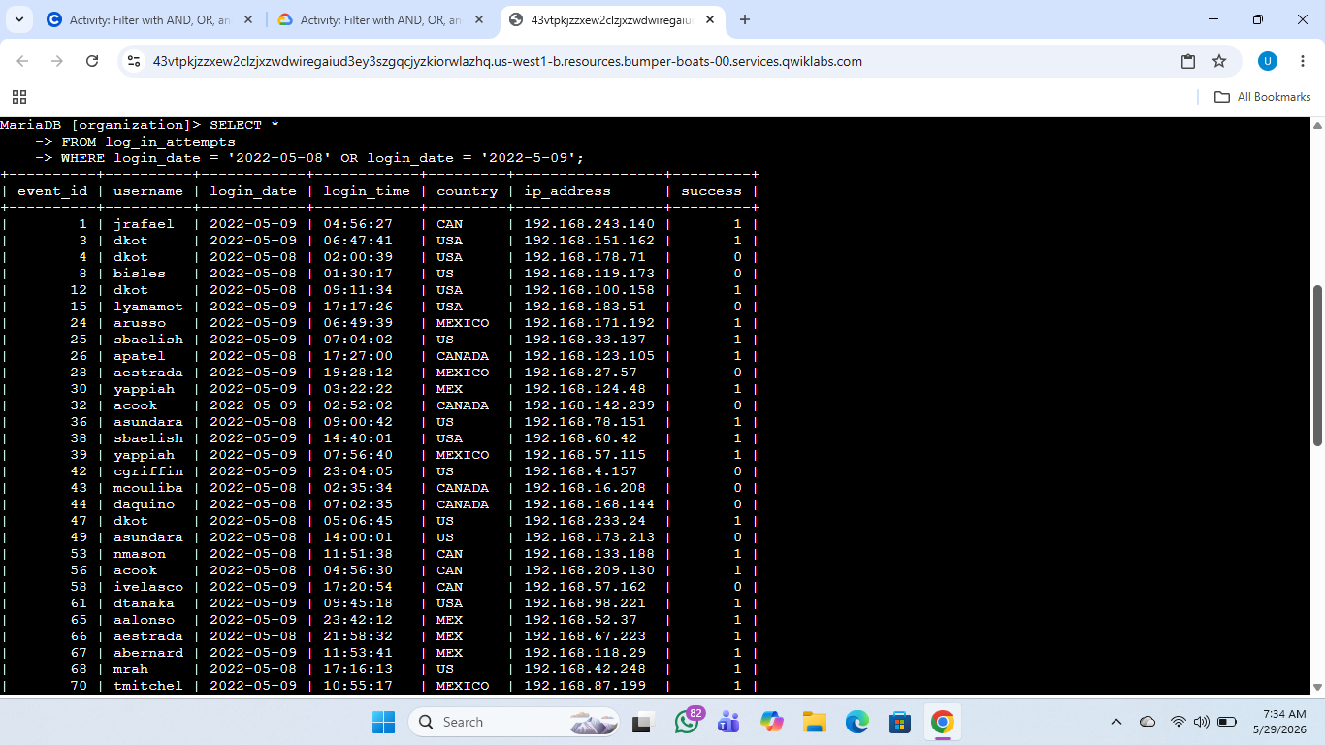

Retrieve login attempts outside of Mexico
To investigate login attempts originating from outside Mexico, I used the following SQL query:

SELECT *
FROM log_in_attempts
WHERE NOT country LIKE 'MEX%';

Query Explanation

This query was designed to retrieve login attempts that originated from locations outside Mexico. Since the database sometimes records the country as "MEX" and other times as "Mexico", a filtering approach was needed to exclude both variations.

The "WHERE" clause is used to apply a condition that filters the data returned by the query.

The "NOT" operator tells the database to exclude a specific condition from the results. In this case, any records matching the specified country pattern are removed from the output.

The "LIKE" operator is used for pattern matching. By using "LIKE 'MEX%'", the query searches for any country value that begins with “MEX”. The percentage sign ("%") acts as a wildcard, meaning it can represent any number of characters after "MEX". This allows the query to match values such as "MEX" and "Mexico".

By combining "NOT" and "LIKE", the query returns login attempts from all countries except those beginning with “MEX”, effectively excluding Mexico-related entries from the results.
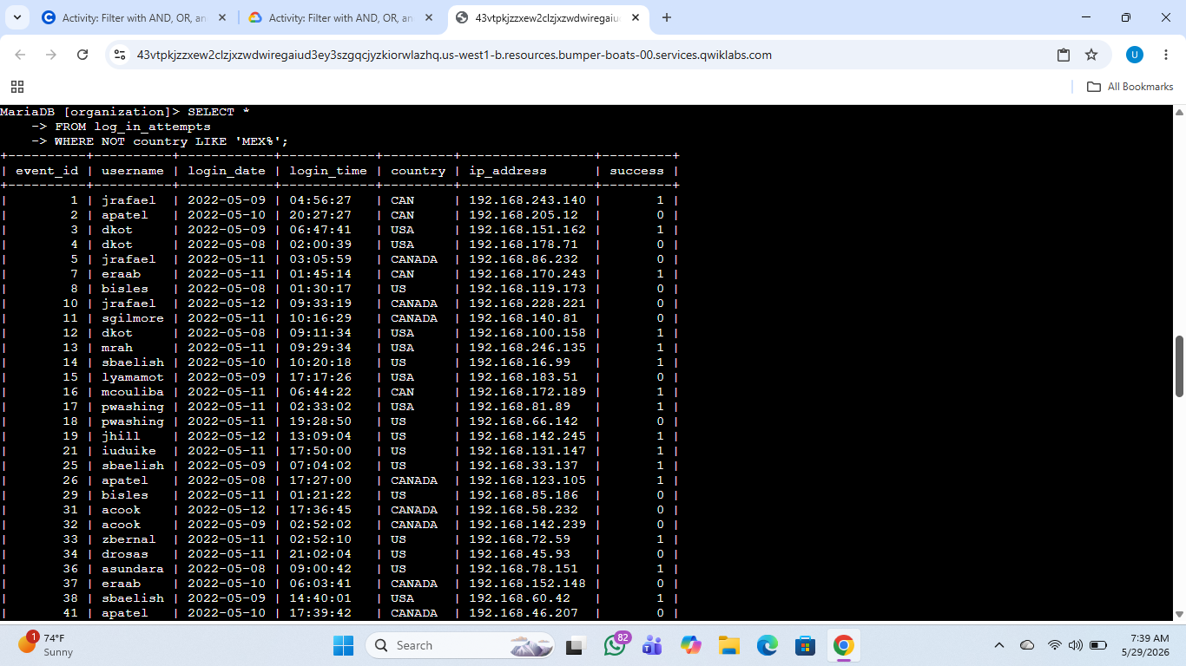

Retrieve employees in Marketing
To retrieve employees in the Marketing department located in offices within the East region, I used the following SQL query:

SELECT *
FROM employees
WHERE department = 'Marketing'
AND office LIKE 'East%';

Query Explanation

This query was designed to retrieve employee records from the "employees" table for staff members who belong to the Marketing department and are located in East offices.

The "FROM employees" statement specifies that the query retrieves data from the "employees" table.

The "WHERE" clause is used to apply filters to the query. The first condition, "department = 'Marketing'", instructs the database to return only employees who belong to the Marketing department.

The "AND" operator is used to combine multiple conditions, meaning that both criteria must be met for a record to appear in the results.

The second condition, "office LIKE 'East%'", filters for office locations that begin with “East”. Since office names may contain variations such as East-170, East-200, or East-300, the "LIKE" operator is used for pattern matching.

The percentage sign ("%") acts as a wildcard, allowing the query to match any office name that starts with “East” regardless of the numbers or characters that follow.

As a result, the query returns only employees who work in the Marketing department and are assigned to offices located in the East region.
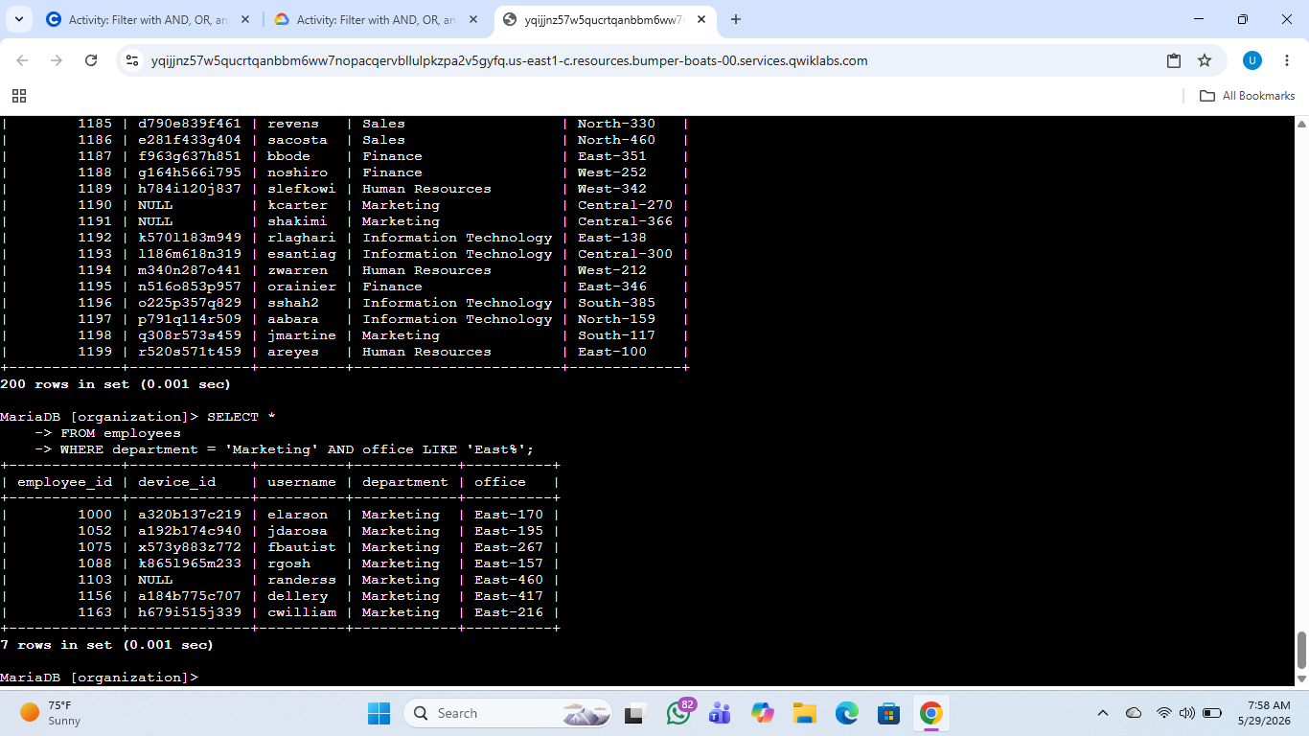

Retrieve employees in Finance or Sales
To identify employees whose machines required a security update, specifically those in the Sales and Finance departments, I used the following SQL query:

SELECT *
FROM employees
WHERE department = 'Finance'
OR department = 'Sales';

Query Explanation

This query was designed to retrieve employee records from the "employees" table for staff members working in either the Finance or Sales departments.

The "WHERE" clause is used to apply filters to the query. In this case, the filter checks the "department" column to identify employees belonging to the required departments.

The "OR" operator is used to specify that records should be returned if either one condition or the other is met. This means the query retrieves employees whose department is Finance or Sales, while excluding employees from all other departments.

By using this query, the company was able to efficiently identify employees in the targeted departments and proceed with the required security updates on their machines.
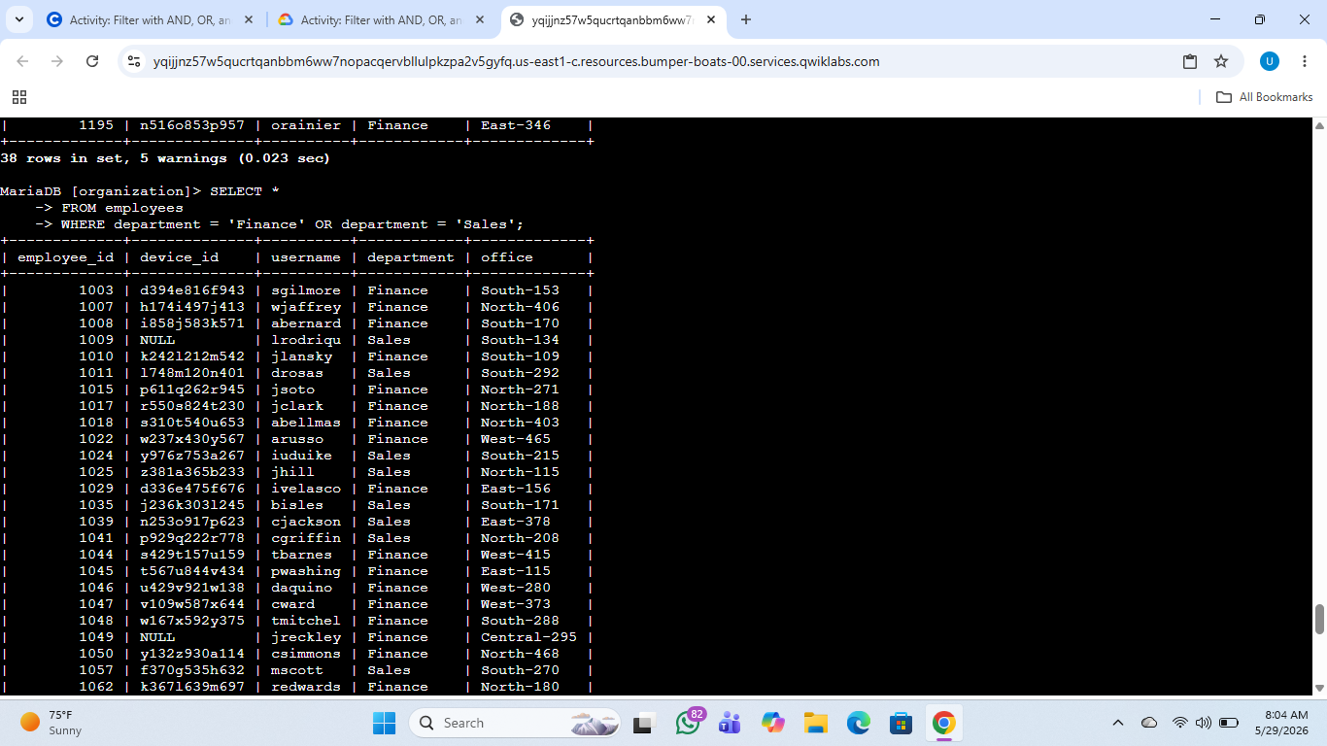

Retrieve all employees not in IT
To identify employees whose machines still required a security update, excluding those in the Information Technology (IT) department whose systems had already been updated, I used the following SQL query:

SELECT *
FROM employees
WHERE NOT department = 'Information Technology';

Query Explanation

This query was designed to retrieve employee records from all departments except the Information Technology department.

The "WHERE" clause is used to apply a filter to the query. In this case, the filter checks the "department" column to determine which department each employee belongs to.

The "NOT" operator is used to exclude a specific condition from the results. By using "NOT department = 'Information Technology'", the query instructs the database to return records for employees whose department is not Information Technology.

As a result, the output includes employees from all other departments while excluding employees in the Information Technology department. This allowed the company to efficiently identify machines that still required the security update.
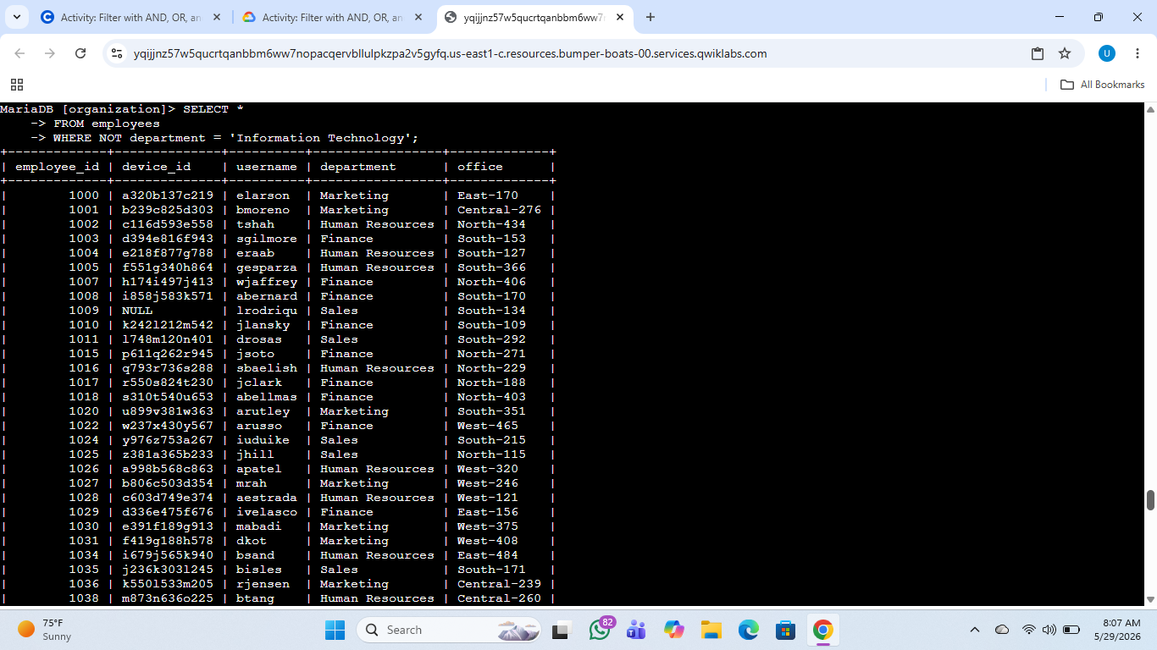

Summary
In summary, understanding SQL queries is an essential skill for a security analyst, as it plays a significant role in day-to-day security operations. The ability to query databases efficiently allows security analysts to retrieve relevant information, investigate suspicious activities, and support incident response and security monitoring processes.

Becoming familiar with SQL operators and filtering techniques such as AND, OR, NOT, LIKE, and comparison operators (such as greater than, less than, and not equal to) is highly important. These commands enable a security analyst to retrieve specific data quickly and accurately, making investigations and administrative tasks more efficient.

Through this project, I gained practical experience in using SQL queries to filter data, retrieve meaningful information, and better understand how database querying supports cybersecurity operations in a real-world environment.

